#Blinkit Grocery Dataset Analysis Dashboard

## Project Description

Welcome to the Blinkit Grocery Dataset Analysis Dashboard repository! This project aims to create an interactive Excel dashboard to analyze and visualize the Blinkit grocery dataset. The dashboard provides valuable insights into sales trends, product performance, and customer behavior, helping users make data-driven decisions.

## Features

- Data Import & Cleaning: Automated processes for importing and cleaning the Blinkit dataset to ensure data consistency.

- Sales Analysis: Interactive charts and metrics to track sales trends, daily sales, and overall performance.

- Product Insights: Analysis of top-selling products, seasonal trends, and inventory metrics.

- User-Friendly Interface: An intuitive dashboard layout with easy navigation and clear summaries of key metrics.

## Getting Started

To get started with this project, follow the instructions below:

### Prerequisites

- Microsoft Excel (version 2016 or later with support for Power Query and Power Pivot)

- Basic understanding of Excel functionalities and data analysis

### Installation

1. Clone the Repository: Clone this repository to your local machine using the following command:

```bash

git clone https://github.com/Aishwarya23-ux/Data_Analysis_Blinkit_DashBoard

```

2. Open the Excel File: Navigate to the cloned repository and open the `Blinkit_Data_Analysis.xlsx` file in Excel.

3. Enable Macros: Make sure to enable macros to fully utilize the interactive features of the dashboard.

## Dataset

The Blinkit grocery dataset includes transaction details such as:

* Item_Identifier
* -Sl _No
* -Item_Weight
* Total_Sales_of_Fat_Item
* -Item_Fat_Content
* -Item_Visibility
* -Item_Type
* -Item_Type
* -Item_MRP
* -Outlet_Identifier
* -Outlet_Establishment_Year
* -Total_Sales

##DashBoard

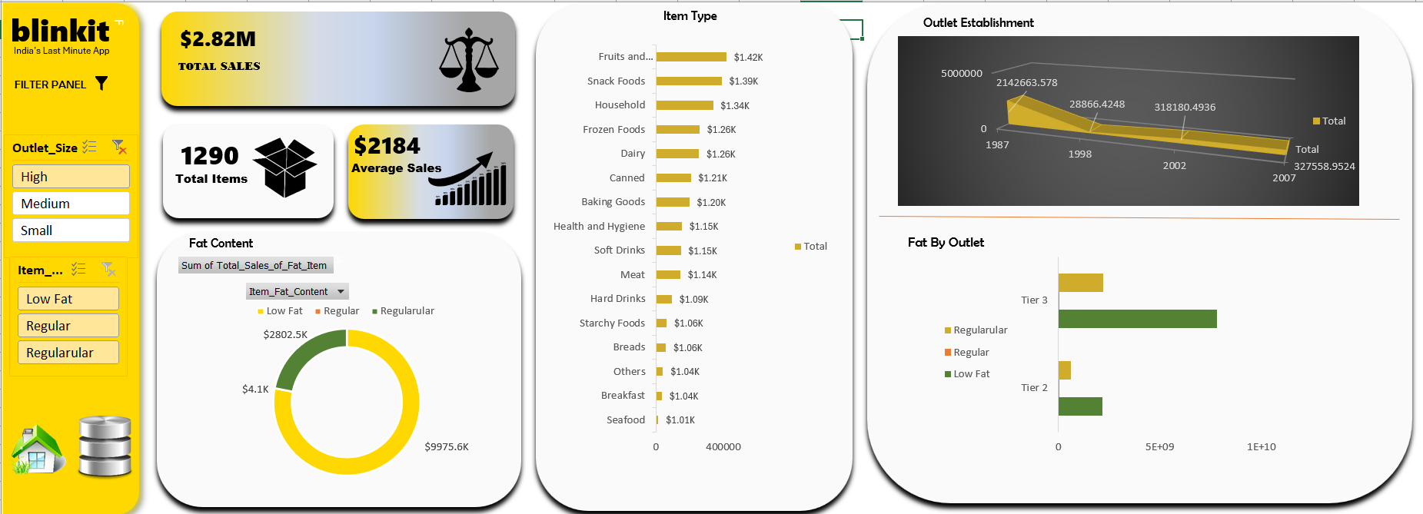

## Contributing

Contributions are welcome! Please fork this repository and submit pull requests for any enhancements or bug fixes. For major changes, open an issue to discuss the proposed changes first.

## License

This project is licensed under the MIT License. See the [LICENSE](./LICENSE) file for more details.

## Acknowledgements

Special thanks to the Kaggel “https://www.kaggle.com/datasets/mukeshgadri/blinkit-dataset” team for providing the dataset and to the open-source community for their continuous support and contributions.

## Contact

For any questions or feedback, please reach out to https://github.com/Aishwarya23-ux/ or open an issue on this repository.

---

Feel free to customize this template to better fit your specific project details and needs. Adding visual aids, such as screenshots or gifs of your dashboard, can also make your README more engaging and helpful. Happy coding!